CHAPTER 3: Evolution
Worksheet 3.5

Ages of fossils
Student: Class:

Relative ages
1. The following cliff face diagram contains numerous rock layers and fossils.
A
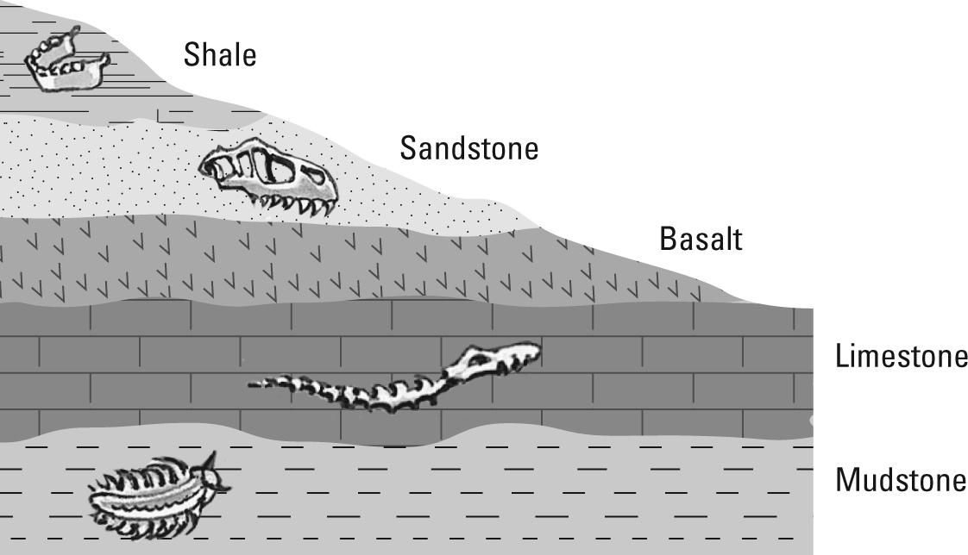
B
D
C

(a) Identify the youngest and oldest sedimentary rock layers in this sequence.

(b) Using the code letters (A–D), arrange the fossils in order from oldest to youngest.

(c) Explain why there are no fossils in the basalt rock layer.

CHAPTER 3: Evolution
Worksheet 3.5

Page 2

Radiometric C-14 dating
2. The absolute ages of recent carbonaceous fossils can be determined using radiocarbon dating.
The half-life of carbon-14 (a radioactive isotope) is 5730 years. The following table shows how the percentage of C-14 present in a fossil decreases over time.
Time (years) | 0 | 5730 | 11 460 | 17 190 | 22 920 | 28 650
% C-14 remaining | 100 | 50 |  | 12.5 | 6.25 | 3.125
(a) Complete the table.
(b) Plot a line graph of this data on the grid below.

(c) The C-14 content of a fossil was found to have decreased by 36% since the organism died. Determine the approximate age of the fossil.

(d) A fossil is approximately 10 000 years old. What percentage of C-14 still remains?

(e) Explain why it is difficult to date fossils that are more than 60 000 years old using radiocarbon dating.

